Interactive session in ViewRecord.R

note, keyboard input shown in red

> source('~/Dropbox/BFM/ViewRecord.R')

enter windowY, suggestion is 10 7

enter window Qp, suggestion is 40 40

enter window Qb, suggestion is 2 1

enter starting Date, no quotes 1995-10-01

enter ending Date, no quotes 2000-12-31

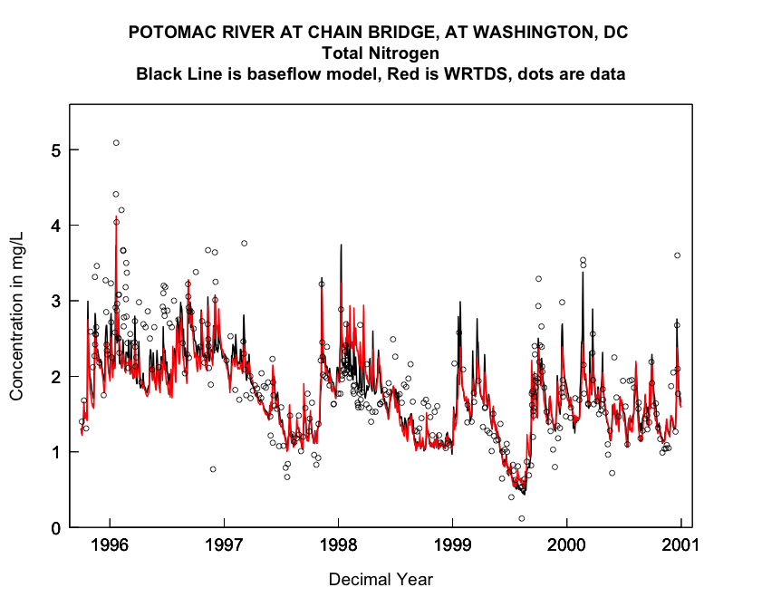

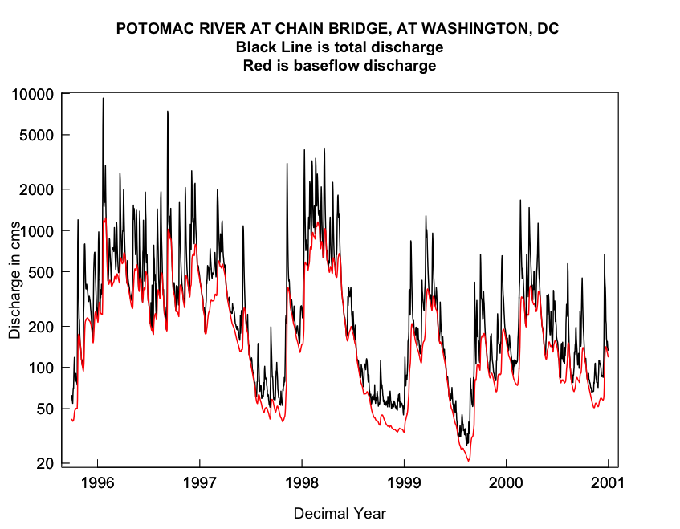

A few comments:

1. There is generally not a huge difference in estimated concentration between WRTDS and the BFM, although in some of the discharge spikes the BFM goes well above WRTDS on the spikes.
2. There are protracted periods when both models have a strong tendency towards positive residuals or negative residuals – there tends to be a strong serial correlation in residuals at time constants of a few months.
3. Neither model tends to show as much variability as the real data. Both models undershoot the high days and overshoot the low days. This is exactly what we would expect. Regression-based models (which is what both of these are) will always give estimates that “regress to the mean” – they are never as variable as the real world.
4. The discharge plot shows that the estimated base flow is often a very large fraction of the total discharge. On some of the highest peak discharge events base flow may rise as much as a factor of 10 in a matter of a few days. At the peak discharge day it may only be 10% of the total discharge, but as discharge begins to fall, in a few days base flow becomes a very large fraction of the total flow again. This is not what I would have expected. I wonder if a different base flow estimation method, that is less “volatile” might be more appropriate?